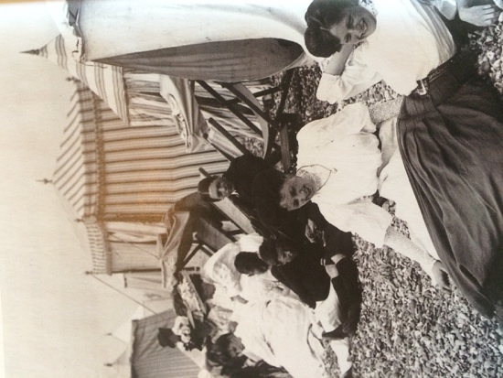  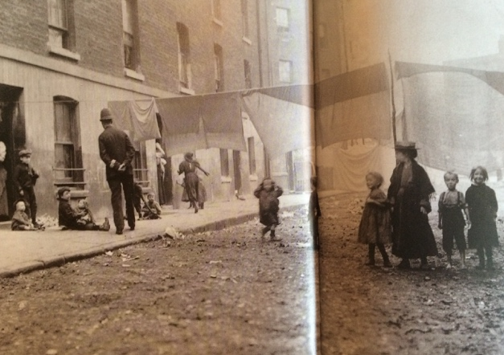 | 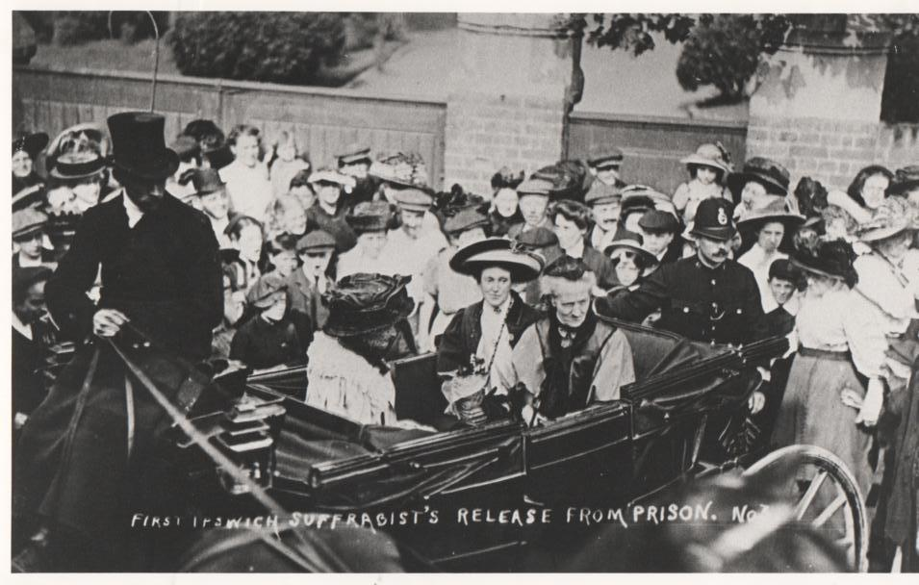
A crowd greets Ipswich suffragette Constance Andrews as she is driven away from prison in May 1911. The Suffragettes campaigned for women to be given the right to vote. Women were given the same voting rights as men in 1928. | People on holiday by the sea in Brighton in 1903 (left) and a picture showing one of the poorest streets in London in 1904 (right). The people living in this street were given no support by their local government or by charities. These pictures show how different life was for different groups of people at the beginning of the 20th century.
Four Indian soldiers at the Brighton Pavilion hospital in 1915. These men were wounded fighting for Britain during the First World War. Approximately 1.5 million Indian men fought for Britain in the First World War, alongside men from other countries across the British Empire. In total, from all the countries involved, there were around 20 million deaths caused by the First World War. | British emigrants leaving Liverpool for Australia in 1913. (This small boat is taking them to a larger boat off-shore.) The Australian government encouraged British people to emigrate by offering them land. Two-thirds of those who emigrated were disappointed by the ‘better life’ and returned home within 15 years.
In 1926 Coal miners went on strike because they were getting less pay. Other workers also went on strike to support them, including bus, train and tram drivers. The strike lasted 9 days. Roads in London were packed as people drove cars, cycled and walked to work instead of taking the bus or tram. The strike ended without miners getting more pay. | This picture shows Arthur Burrows reading the news for the first ever radio programme from the BBC, in November 1922. The radio was then usually called the wireless.
 | 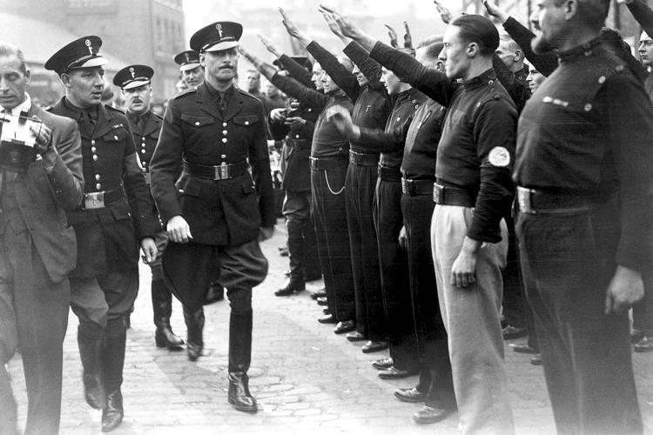
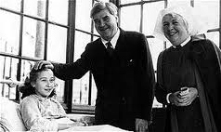
Sir Oswald Mosley, leader of the British Union of Fascists inspecting a parade of female members of the Union in 1936. Mosley encouraged his followers to attack Jewish people. He was imprisoned during the Second World War because of his support for the fascist leaders Hitler, in Germany, and Mussolini, in Italy, who the British were fighting against. | The first Christmas Day message by a British monarch was in 1932, when King George V broadcast live on the wireless. The King spoke about the fact that the wireless meant he could make the same speech to people across the British Empire for the first time.
The Second World War began in 1939. From 1940-1941 the German Airforce bombed Britain. This bombing was called the Blitz. This picture shows King George VI and his wife Queen Elizabeth (the parents of Queen Elizabeth II) inspecting bomb damage at Buckingham Palace in 1940. The King and Queen stayed in Buckingham Palace throughout the Blitz, even though the government told them they should leave. | Jewish Kindertransport children arriving in London in February 1939. From 1938-1939 Jewish children were evacuated from Nazi Germany by societies and charity groups. 10000 of them came to Britain. The Nazi Party and their leader Hitler were anti-Semitic and started to make laws against Jewish people in 1933 as soon as they came to power, in 1938 they became openly violent towards Jewish people.
In June 1948 the Empire Windrush arrived at Tilbury Docks in Essex carrying 492 migrants from Jamaica. After the Second World War Britain encouraged immigration by making all citizens of Commonwealth countries British citizens. Many came because they were promised jobs with good pay. | The National Health Service began in July 1948. This provided free health care for everyone in Britain for the first time. This picture shows Aneurin Bevan, the Minister for Health who created the NHS, with one of the first NHS patients.
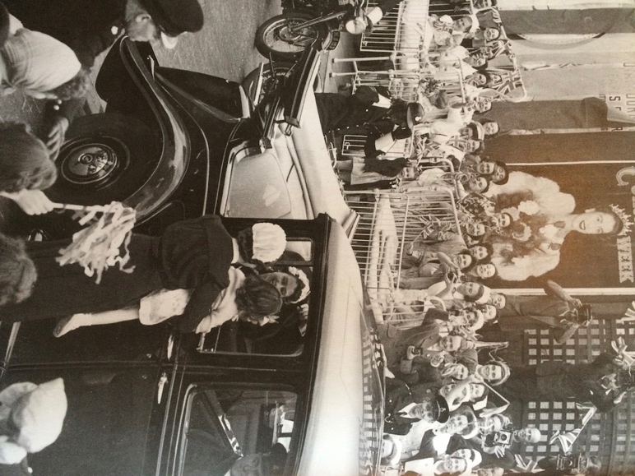 | 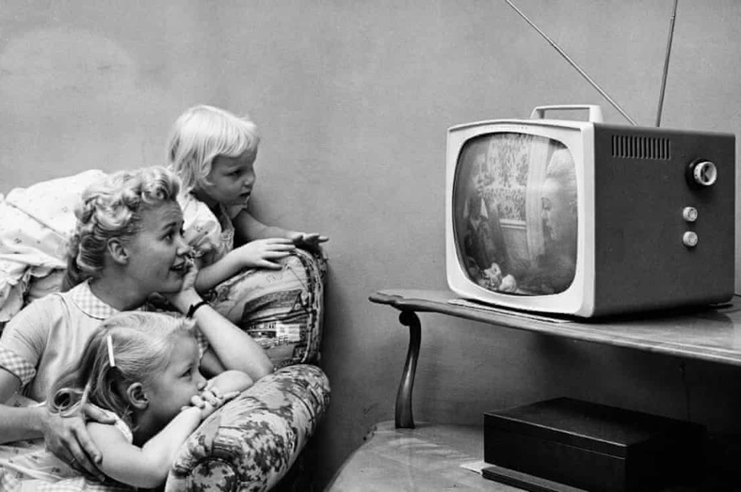
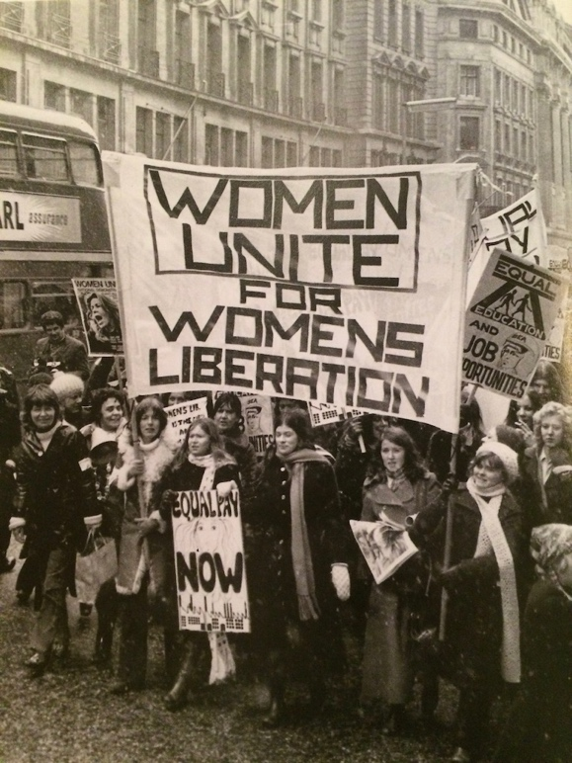
By 1955 95% of the UK could receive television broadcasts in their homes. The television had first been demonstrated in London in 1926. Television became widely popular in the 1960s and 1970s. | This picture shows the newly crowned Queen Elizabeth II greeting patients from the Kennington Children’s Hospital during the week after her coronation. She was coronated in 1953.
In 1968 politician Enoch Powell made a speech which has come to be known as the “rivers of blood” speech. In it he criticised the government for its policy on immigration and for the Race Relations Act which would stop people being discriminated against because of their race. Powell was sacked from his role in Parliament the day after the speech, but this picture shows that he received a lot of support across the country. | In July 1966 England won the World Cup against West Germany at the Wembley Stadium. This picture shows Bobby Moore the England captain with the trophy. This was England’s first and only (so far) World Cup victory.
In the 1960s many South Asians living in African countries that had been part of the British Empire chose to move to Britain. In 1972 the dictator of Uganda gave all South Asians living there 90 days to leave the country, or face severe persecution. About 27,000 came to the UK. This picture shows Ugandan Indians arriving at Stansted. | This picture shows a march for Women’s Liberation in 1971. The ‘Women’s Lib’ movement fought for equal pay, equal education and equal job opportunities for women.
 | 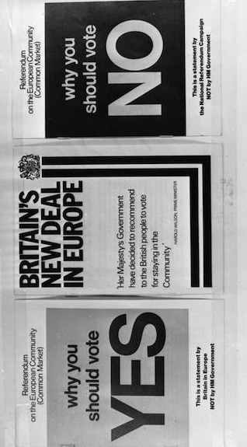
 | 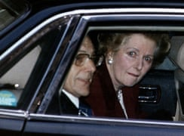
 | 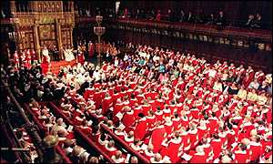
Britain had joined the European Community (which later became the EU) in 1973 under a Conservative government. In 1975 the Labour government held a referendum asking if Britain should stay in, 67% voted to stay. This picture shows some of the campaign and information leaflets before the referendum. | In 1974 Britain was struggling to make enough electricity because of coal miners striking for higher pay. The government created a ‘three-day week’ which meant that businesses could only use electricity for three days a week. This picture shows women at a duvet factory working by candle light and wrapped in duvets to stay warm.
This picture shows the Prime Minister Margaret Thatcher leaving 10 Downing Street after she resigned in 1990. Thatcher was the first female prime minister of Britain. In this picture Thatcher is in tears. She resigned because her policies became more and more unpopular until her own party turned against her. One of her most unpopular policies was closing many of Britain’s coal mines which led to strikes and violence between miners and the police. | In 1958 the Campaign for Nuclear Disarmament (CND) was started by people who were afraid that nuclear war would lead to the death of the entire population of Britain. The CND encouraged protests against nuclear weapons in Britain. This picture shows CND protestors in Ipswich in April 1982.
In 1999 the House of Lords Act created a big change in the Houses of Parliament. Instead of the House of Lords being filled with members who had inherited their right to be there, they would now be chosen by the government. Only 92 hereditary peers were allowed to stay out of 650. | The IRA was a militant organisation whose aim was for the whole of the island of Ireland to be united and not part of the UK. From 1969-1994 the IRA carried out a bombing campaign. The threat of a terrorist attack became a normal part of life, there were few public bins in London, and many London letter boxes were sealed up. This picture shows Wormwood Street in London after the IRA had set off a truck bomb in April 1993.

